Variant | Structure | Properties
P40763 M1V | 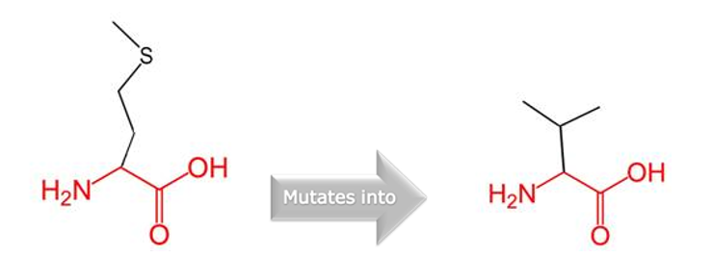 | - The wild-type and mutant amino acids differ in size.  - The mutant residue is smaller, this might lead to loss of interactions.
P40763 K531R | 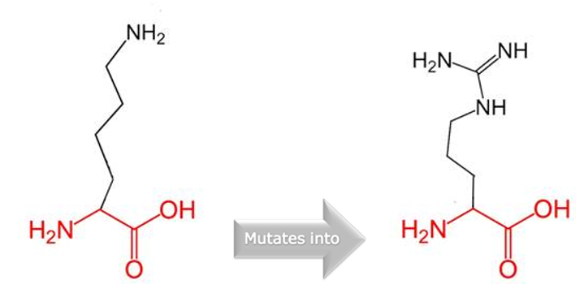 | - The wild-type and mutant amino acids differ in size.  - The mutant residue is bigger than the wild-type residue.  - The residue is located on the surface of the protein, mutation of this residue can disturb interactions with other molecules or other parts of the protein.
P40763 G684R | 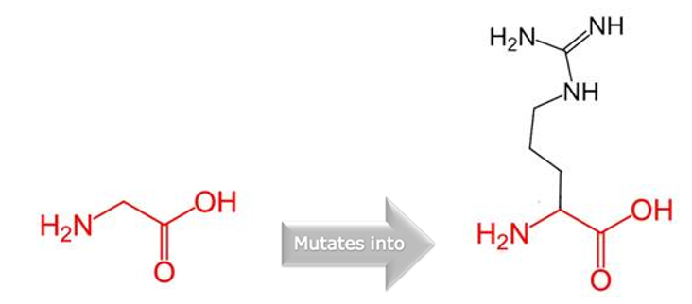 | - There is a difference in charge between the wild-type and mutant amino acid.  - The mutation introduces a charge at this position, this can cause repulsion between the mutant residue and neighboring residues.  - The wild-type and mutant amino acids differ in size.  - The mutant residue is bigger than the wild-type residue.  - The residue is located on the surface of the protein, mutation of this residue can disturb interactions with other molecules or other parts of the protein.  - The torsion angles for this residue are unusual. only glycine is flexible enough to make these torsion angles, mutation into another residue will force the local backbone into an incorrect conformation and will disturb the local structure.
P40763 M1L | 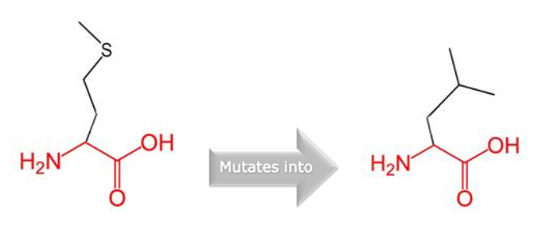 | - The wild-type and mutant amino acids differ in size.  - The mutant residue is smaller, this might lead to loss of interactions.
P40763 Y672H | 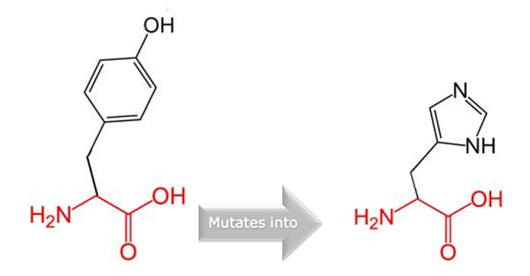 | - The wild-type and mutant amino acids differ in size.  - The mutant residue is smaller than the wild-type residue.  - The mutation will cause an empty space in the core of the protein.  - The hydrophobicity of the wild-type and mutant residue differs.  - The mutation will cause loss of hydrophobic interactions in the core of the protein.
P40763 T756I | 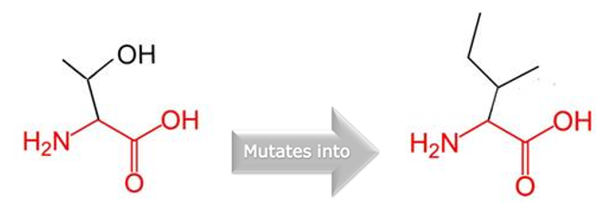 | - The wild-type and mutant amino acids differ in size.  - The mutant residue is bigger, this might lead to bumps.  - The hydrophobicity of the wild-type and mutant residue differs.  - The mutation introduces a more hydrophobic residue at this position. This can result in loss of hydrogen bonds and/or disturb correct folding.
P40763 E523K | 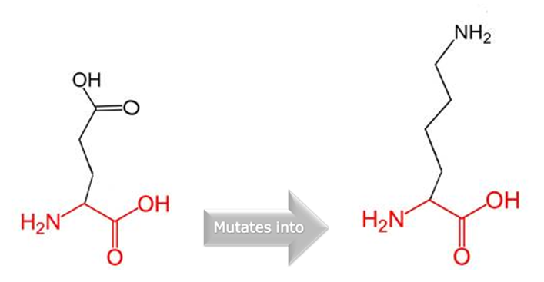 | - There is a difference in charge between the wild-type and mutant amino acid.  - The charge of the buried wild-type residue is reversed by this mutation, this can cause repulsion between residues in the protein core.  - The wild-type and mutant amino acids differ in size.  - The mutant residue is bigger than the wild-type residue.  - The wild-type residue was buried in the core of the protein. The mutant residue is bigger and probably will not fit.
P40763 V507F | 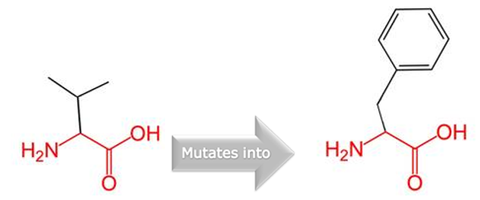 | - The wild-type and mutant amino acids differ in size.  - The mutant residue is bigger than the wild-type residue.  - The residue is located on the surface of the protein, mutation of this residue can disturb interactions with other molecules or other parts of the protein.
P40763 D24N | 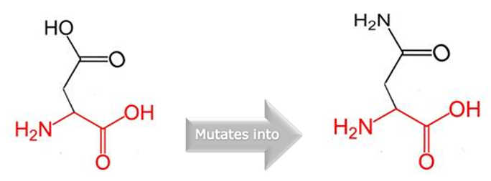 | - There is a difference in charge between the wild-type and mutant amino acid.  - The charge of the wild-type residue is lost by this mutation. This can cause loss of interactions with other molecules.
P40763 M317I | 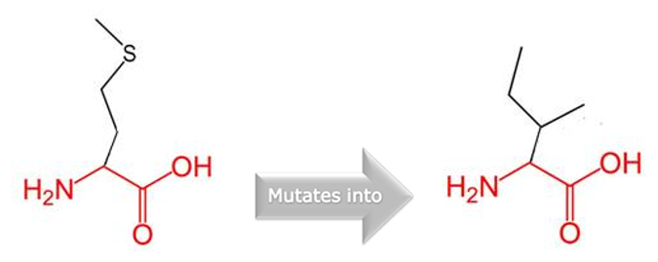 | - The wild-type and mutant amino acids differ in size.  - The mutant residue is smaller than the wild-type residue.  - This will cause a possible loss of external interactions.
P40763 M427R | 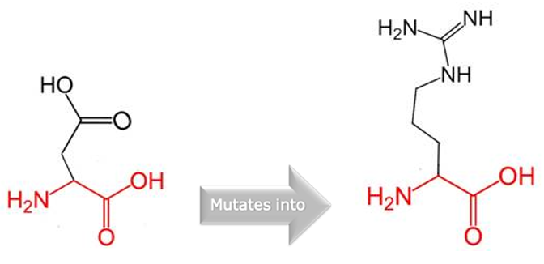 | - There is a difference in charge between the wild-type and mutant amino acid.  - The mutation introduces the opposite charge at this position. This possibly disrupts contacts with other molecules.  - The wild-type and mutant amino acids differ in size.  - The mutant residue is bigger than the wild-type residue.  - The residue is located on the surface of the protein, mutation of this residue can disturb interactions with other molecules or other parts of the protein.
P40763 T663A | 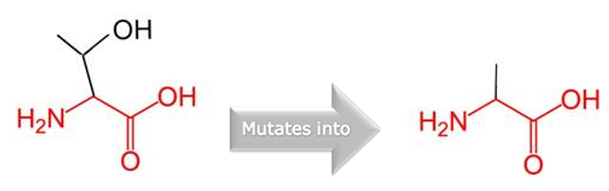 | - The wild-type and mutant amino acids differ in size.  - The mutant residue is smaller than the wild-type residue.  - The mutation will cause an empty space in the core of the protein.  - The hydrophobicity of the wild-type and mutant residue differs.  - The mutation will cause loss of hydrogen bonds in the core of the protein and as a result disturb correct folding.
P40763 L673V | 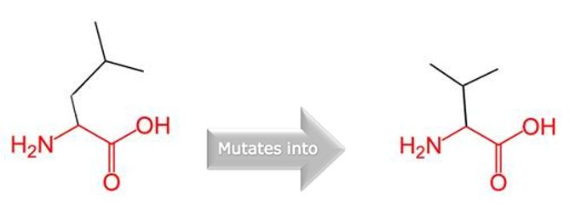 | - The wild-type and mutant amino acids differ in size.  - The mutant residue is smaller than the wild-type residue.  - This will cause a possible loss of external interactions.
P40763 P458H | 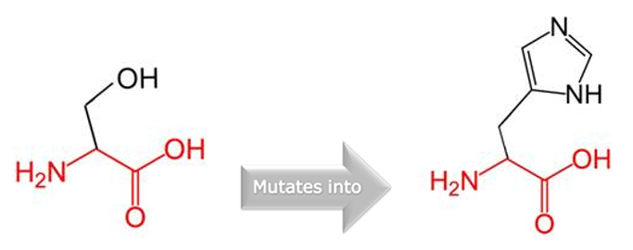 | - The wild-type and mutant amino acids differ in size.  - The mutant residue is bigger than the wild-type residue.  - The wild-type residue was buried in the core of the protein. The mutant residue is bigger and probably will not fit.  - The hydrophobicity of the wild-type and mutant residue differs.  - The mutation will cause loss of hydrophobic interactions in the core of the protein.
P40763 R688W | 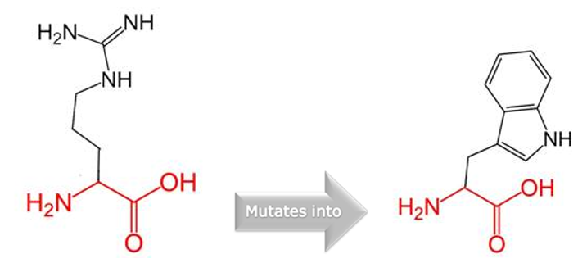 | - There is a difference in charge between the wild-type and mutant amino acid.  - The charge of the buried wild-type residue is lost by this mutation.  - The wild-type and mutant amino acids differ in size.  - The mutant residue is bigger than the wild-type residue.  - The wild-type residue was buried in the core of the protein. The mutant residue is bigger and probably will not fit.  - The hydrophobicity of the wild-type and mutant residue differs.  - The mutation will cause loss of hydrogen bonds in the core of the protein and as a result disturb correct folding.
P40763 I101L | 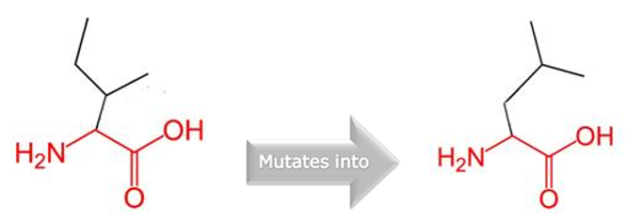 | - There are no differences in the amino acid properties and no structural information was found using the databases and web services.
P40763 Y640S | 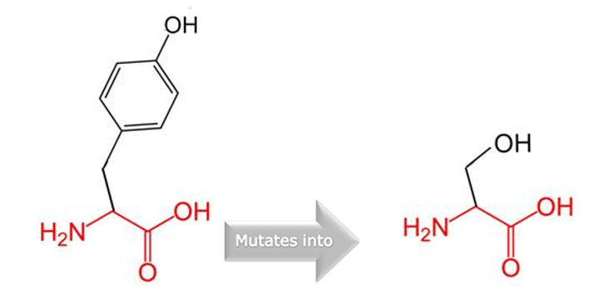 | - The wild-type and mutant amino acids differ in size.  - The mutant residue is smaller than the wild-type residue.  - The mutation will cause an empty space in the core of the protein.
P40763 I425F | 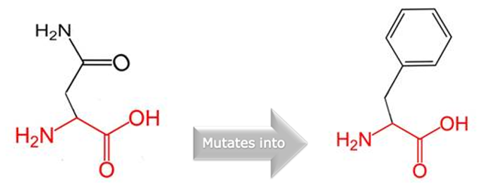 | - The wild-type and mutant amino acids differ in size.  - The mutant residue is bigger than the wild-type residue.  - The residue is located on the surface of the protein, mutation of this residue can disturb interactions with other molecules or other parts of the protein.  - The hydrophobicity of the wild-type and mutant residue differs.
P40763 A422T | 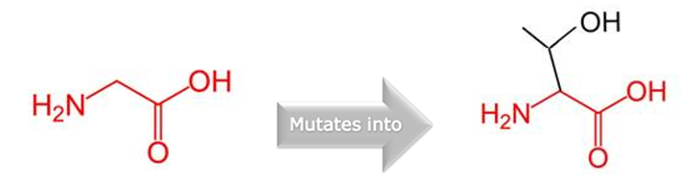 | - The wild-type and mutant amino acids differ in size.  - The mutant residue is bigger than the wild-type residue.  - The wild-type residue was buried in the core of the protein. The mutant residue is bigger and probably will not fit.  - The torsion angles for this residue are unusual. only glycine is flexible enough to make these torsion angles, mutation into another residue will force the local backbone into an incorrect conformation and will disturb the local structure.
P40763 R518Q | 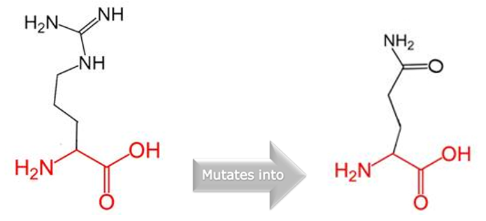 | - There is a difference in charge between the wild-type and mutant amino acid.  - The charge of the wild-type residue is lost by this mutation. This can cause loss of interactions with other molecules.  - The wild-type and mutant amino acids differ in size.  - The mutant residue is smaller than the wild-type residue.  - This will cause a possible loss of external interactions.

